University Management System
Submitted By
Muhammad Numan 2025(S)SE_19
Mirza zain Baig 2025(S)SE_20
Arslan Mohsin 2025(S)SE_07

Submitted To
Sir Syed Hassan

1. Project Overview
This project implements a relational database for a university. It manages students, faculty, departments, and course enrollments. The system is designed to maintain data integrity using primary and foreign keys and includes advanced features like database triggers and virtual views.

2. Database Schema Design
The database consists of 8 tables designed to handle various types of relationships:
Core Tables
- Departments & Programs: A hierarchical relationship where one department can host multiple degree programs.
- Faculty & Offices: Demonstrates a 1:1 (One-to-One) relationship, ensuring each faculty member has exactly one unique office assigned.
- Courses & Sections: Courses are the general definitions, while Sections are the specific instances (time/place) taught by a faculty member.
- Students: Linked to their respective degree programs.
- Enrollments: A Junction Table that handles the M:N (Many-to-Many) relationship between Students and Sections, allowing a student to take many classes and a class to have many students.
3. Implementation Highlights
Data Integrity & Constraints
- Primary Keys: Used in every table to ensure unique identification of records.
- Foreign Keys: Used to enforce referential integrity (e.g., you cannot enroll a student in a section that doesn't exist).
- Unique Constraints: Applied to the offices table to prevent two faculty members from being assigned the same room.
- For example:
- 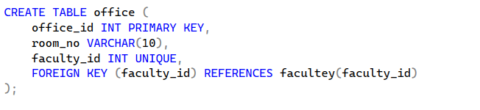
Advanced Database Objects
- Views (dept_summary): Provides an abstraction layer, allowing users to see department names and HODs without accessing the full table.
- Example:
- 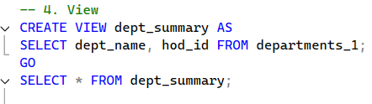
- Subqueries: Included a query to identify "High Earners" by comparing individual faculty salaries against the global average.
- Example
- 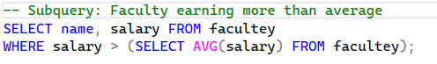
- Triggers (trg_check_credits): A business logic rule that automatically prevents data entry errors by rolling back any transaction where course credits are set to zero or less.
- Example
- 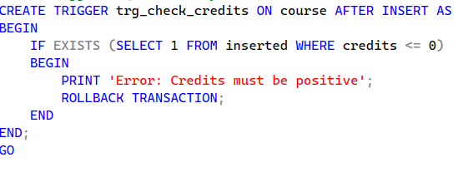

Screen shots of Outputs
1.
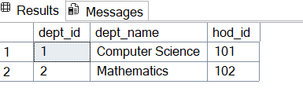
2.
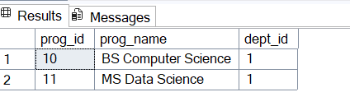
3.
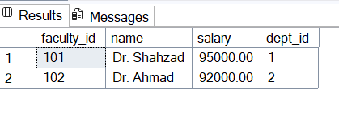
4.
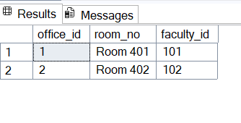
5.
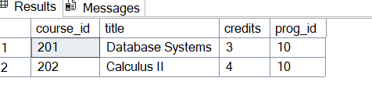
6.
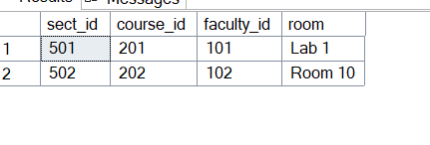
7.
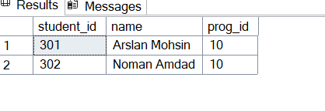
8.
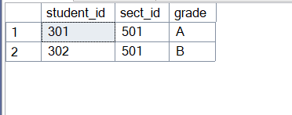
9.
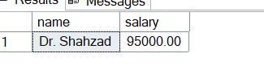
10.
11. 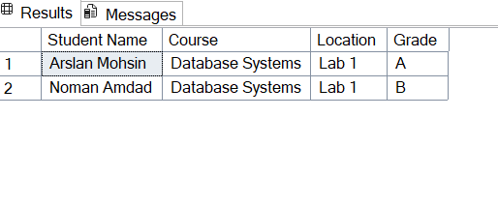
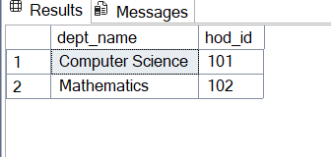

ER Diagram

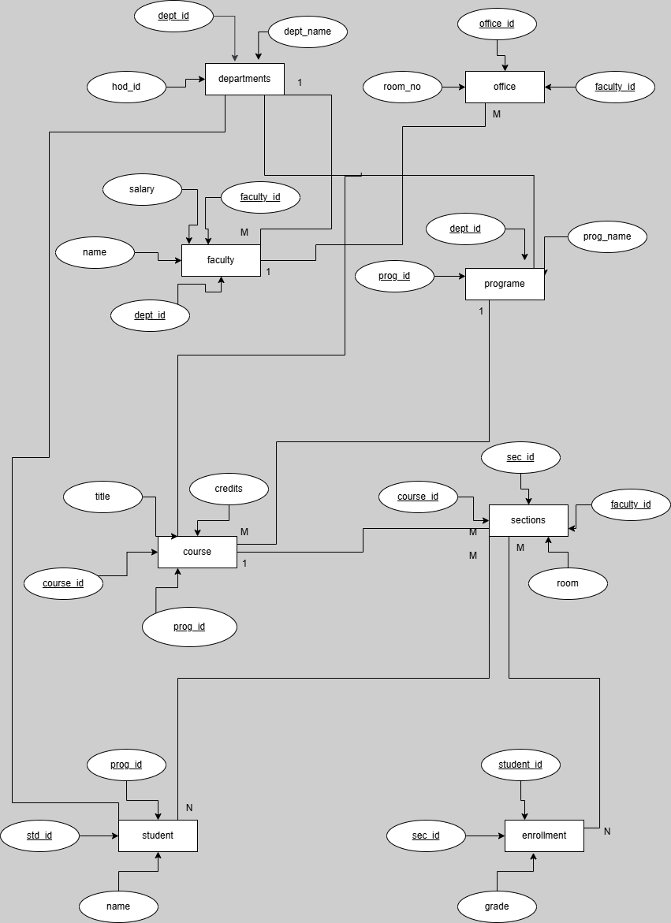
5. Conclusion
The university_db provides a robust foundation for academic data management. By utilizing normalization, junction tables, and triggers, the system ensures that data remains consistent, accurate, and easy to retrieve for administrative reporting.
______________________________________________

